Lab 10 : Bloblang for Stream Transformation & PII Removal

Table of Contents
Table of Contents 2
Introduction 3
Learning Objectives 3
Prerequisites 3
Part 1 — Setup Cloud Topics 4
Part 2 — Write the Bloblang Pipeline 5
Bloblang Breakdown 6
Part 3 — Execute and Test the Pipeline 7
Step 1 — Run Redpanda Connect 7
Step 2 — Produce Test Data 7
Part 4 — Verify the Transformations 8
What Happened? 8
Knowledge Check 9
Troubleshooting 9
Symptom: Pipeline crashes with mapping failed: field 'device': value is null 9
Symptom: No messages appear in enriched-telemetry 9
Next Steps 10
Conclusion 10

Introduction
Moving data from Point A to Point B is only half the battle. Real-world streaming data is often messy, deeply nested, or contains sensitive Personally Identifiable Information (PII) that must be removed before it lands in a database or data lake.
Bloblang is Redpanda Connect's native mapping language. It is incredibly fast, safe, and designed specifically for manipulating JSON payloads in flight.
In this lab, you will write a declarative pipeline that ingests raw telemetry events. Using Bloblang, you will:
- Filter out unwanted test events.
- Enrich the payload with a processing timestamp.
- Mask PII by redacting customer email addresses.
- Map deeply nested fields into a flattened structure.

Learning Objectives
Upon completing this lab, you will be able to:
- Understand core Bloblang syntax (root, this, assignment, and deletion).
- Write conditional logic (if / else) to route or drop streaming data.
- Use Bloblang utility functions like now() and deleted().
- Sanitize and restructure JSON payloads in real-time.

Prerequisites
Before starting, ensure you have:
- rpk installed and authenticated to your Serverless cluster (rpk cloud login).
- Docker installed and running.
- Your Serverless Bootstrap Server URL, Username, and Password (refer to lab 4).
(Ensure your cloud user has ACLs allowing them to read/write to all topics and consumer groups).

Part 1 — Setup Cloud Topics
We need a source topic for our raw, messy data, and a destination topic for our clean, enriched data.
Open your terminal and create the topics:
rpk topic create raw-telemetry

rpk topic create enriched-telemetry

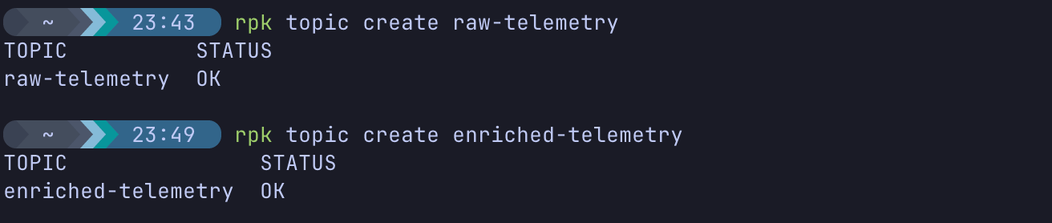
Expected Output:
TOPIC STATUS
raw-telemetry OK
enriched-telemetry OK

Part 2 — Write the Bloblang Pipeline
Create a new directory for your transformation labs:
mkdir ~/rp-bloblang-labs
cd ~/rp-bloblang-labs

Create the pipeline configuration file:
nano enrichment_pipeline.yaml

Paste the following configuration. Update the addresses, user, and password fields with your Redpanda Cloud credentials!
input:
kafka:
addresses: [ "YOUR_BOOTSTRAP_SERVER_URL:9092" ]
topics: [ "raw-telemetry" ]
consumer_group: "bloblang-enrichment-group"
tls:
enabled: true
sasl:
mechanism: SCRAM-SHA-256
user: "your_username"
password: "your_password"
pipeline:
processors:
- bloblang: |
# 1. Conditional Filtering: Drop the message if it is a test event
root = if this.event_type == "test" { deleted() } else { this }
# 2. Enrichment: Inject a processing timestamp
root.processed_at = now()
# 3. PII Removal: Redact the user's email address
root.user.email = "REDACTED"
# 4. Flattening: Move nested OS data to the root level, then delete the old object
root.device_os = this.device.os
root.device = deleted()
output:
kafka:
addresses: [ "YOUR_BOOTSTRAP_SERVER_URL:9092" ]
topic: "enriched-telemetry"
tls:
enabled: true
sasl:
mechanism: SCRAM-SHA-256
user: "your_username"
password: "your_password"

(Save and exit using Ctrl+X, Y, Enter).

Bloblang Breakdown
- this refers to the incoming, original message.
- root refers to the outgoing, mapped message. Setting root = this copies the entire original message over so we can modify it.
- deleted() is a special Bloblang function that removes a field (or drops the entire message if assigned to root).

Part 3 — Execute and Test the Pipeline

Step 1 — Run Redpanda Connect
Launch the pipeline via Docker:
docker run --rm -it \
-v $(pwd):/data \
redpandadata/connect:latest \
-c /data/enrichment_pipeline.yaml

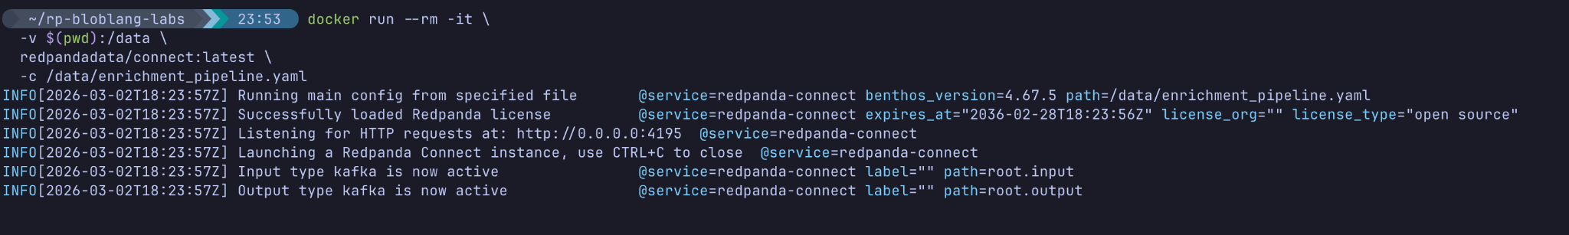
Leave this terminal running. It is now listening to the raw-telemetry topic.

Step 2 — Produce Test Data
Open a second terminal window and produce some data. We will send one valid event and one "test" event.
rpk topic produce raw-telemetry

Paste the following two JSON payloads (press Enter after each):
{"event_type": "purchase", "amount": 150, "user": {"name": "Alice", "email": "alice@example.com"}, "device": {"os": "iOS", "version": "17.1"}}
{"event_type": "test", "amount": 0, "user": {"name": "TestBot", "email": "bot@test.com"}, "device": {"os": "Linux", "version": "1.0"}}

(Press Ctrl+D to exit).

Part 4 — Verify the Transformations
Let's check the destination topic to see how Bloblang handled our data.
rpk topic consume enriched-telemetry -o start

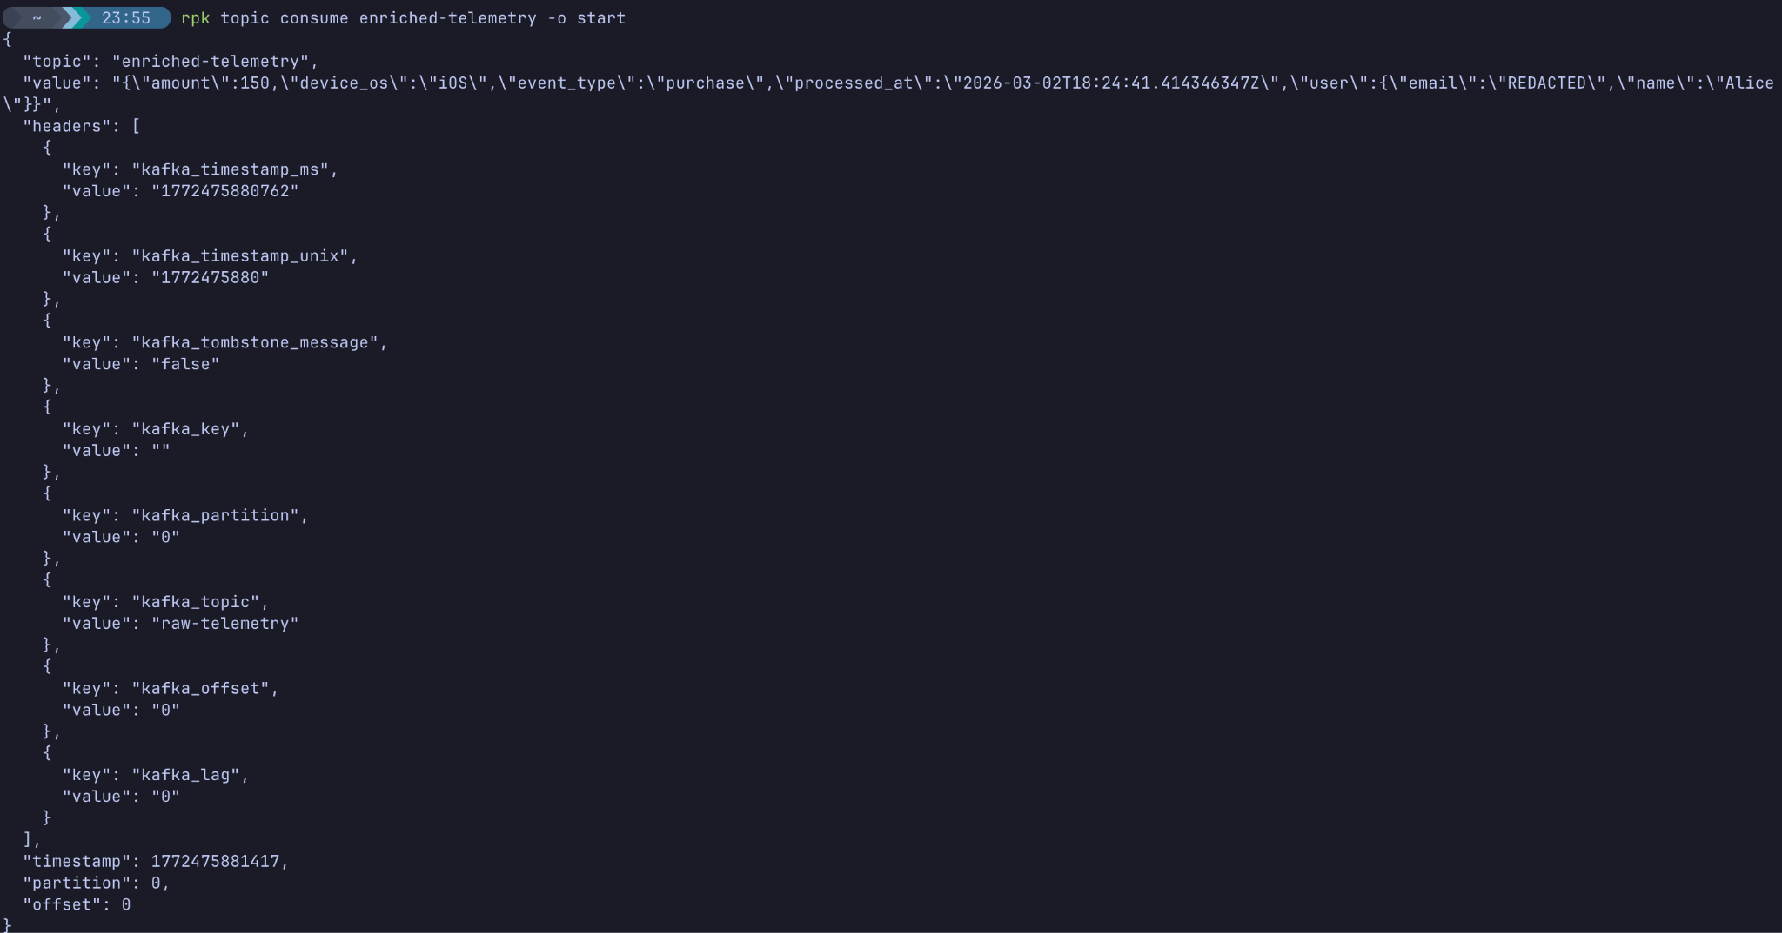

What Happened?
- Filtering Worked: The second message ("event_type": "test") is completely missing! Bloblang's deleted() function successfully dropped it from the stream.
- Enrichment Worked: The processed_at field was dynamically generated and added.
- PII Masking Worked: Alice's email is now "REDACTED".
- Flattening Worked: "device_os": "iOS" is now at the root level, and the nested device object is gone.
(Press Ctrl+C to exit the consumer, and stop your Docker container in the first terminal).

Knowledge Check
- What is the difference between this and root in a Bloblang mapping?
  - Answer: this refers to the immutable incoming document. root refers to the mutable outgoing document being built.
- How do you drop an entire message from the pipeline using Bloblang?
  - Answer: By assigning the deleted() function to root (e.g., root = deleted()).
- Why is doing PII removal in-flight (via Bloblang) better than doing it in a downstream database?
  - Answer: It ensures sensitive data never touches persistent storage (like Redpanda topics, Iceberg, or Snowflake), greatly simplifying compliance (GDPR, HIPAA, PCI) and security audits.

Troubleshooting

Symptom: Pipeline crashes with mapping failed: field 'device': value is null
Solution: If you produce a JSON payload that is missing the device object, Bloblang will throw an error when it tries to read this.device.os. In the next lab, we will learn how to handle missing fields and errors gracefully!

Symptom: No messages appear in enriched-telemetry
Solution: Ensure your JSON payload was formatted correctly and that event_type was not set to "test". If it was, the pipeline did its job and deleted the message!

Next Steps
Keep your terminal handy. In next lab, we will intentionally break our Bloblang mappings using bad data, learn how to handle exceptions, and use the Redpanda Console UI to troubleshoot mapping failures.

Conclusion
In this lab, you harnessed the power of Bloblang. You successfully transformed complex, nested JSON streams, masked sensitive PII in real-time, and implemented conditional routing all while maintaining the declarative, easy-to-read nature of a YAML pipeline.

